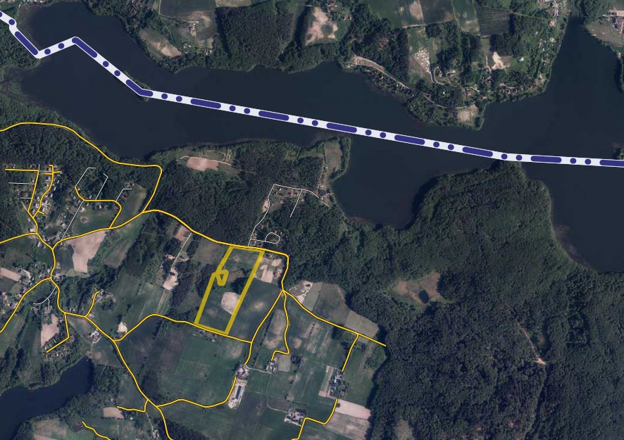

Działki nr: 307/4; 307/5; 307/6; 307/7; 307/8; 307/9; 307/12; 307/13; 307/14; 307/15; 307/16; 307/17; 307/18; 307/19; 307/20; 307/21; 307/22; 307/23; 307/24; 307/25; 307/26; 307/31; 307/32; 307/33; 307/34; 307/35; 307/36; 307/37; 307/38; 307/39; 307/40; 307/41; 307/42, obręb Czaple