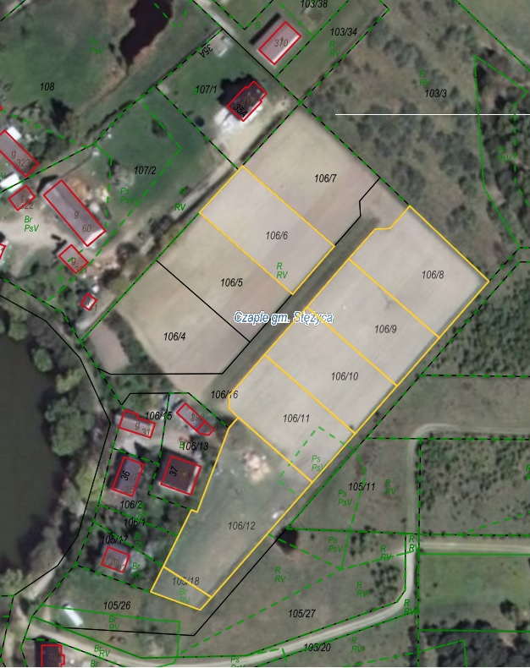

Działki nr: 106/6, 106/8, 106/9, 106/10, 106/11, 106/12 i 105/18 obr. Czaple