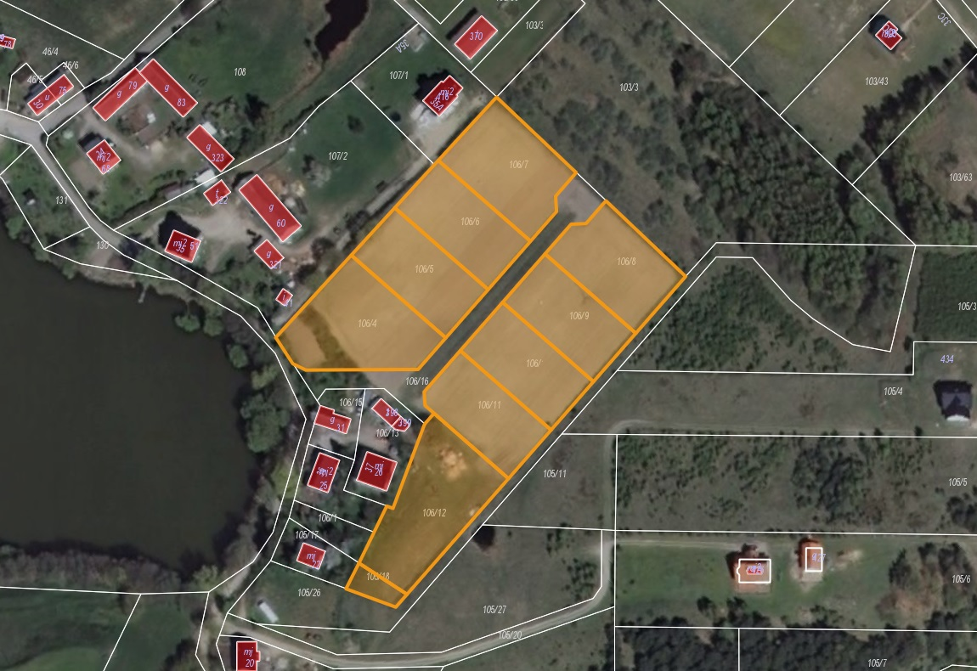

Działki nr: 106/4, 106/5, 106/6, 106/7, 106/8, 106/9, 106/10, 106/11, 106/12 i 105/18 obr. Czaple