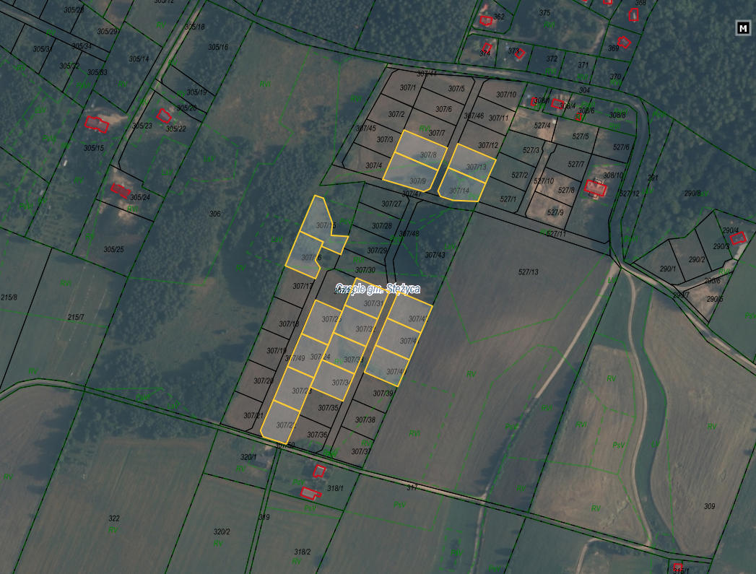

Działki nr: 307/8, 307/9, 307/13, 307/14, 307/15, 307/16, 307/22, 307/23, 307/24, 307/25, 307/31, 307/32, 307/33, 307/34, 307/40, 307/41, 307/42, obręb Czaple