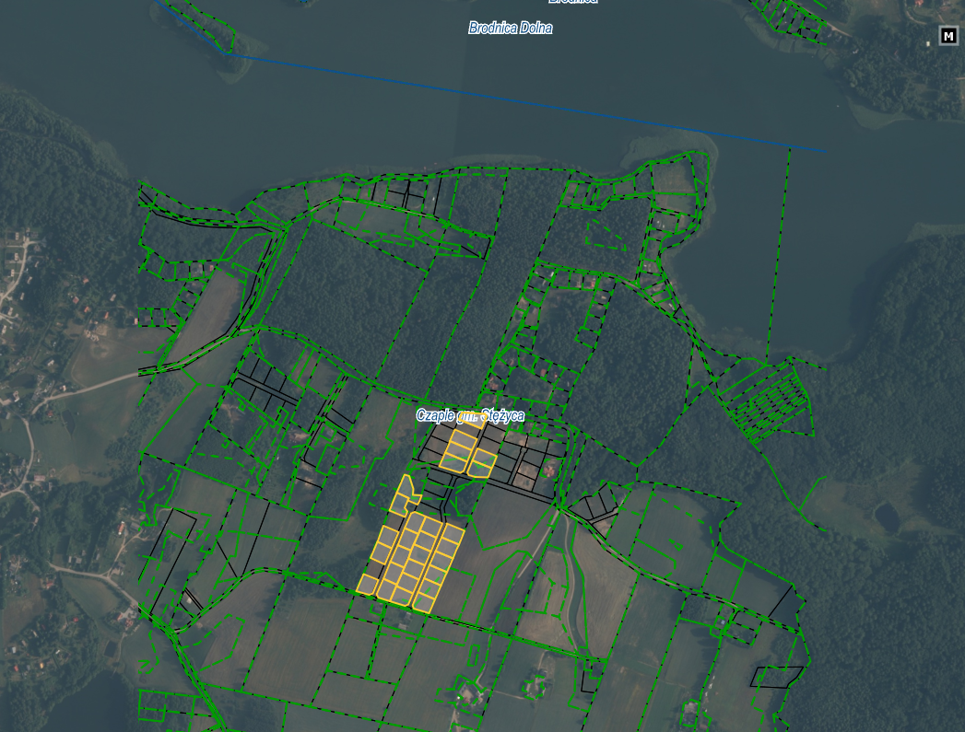

Działki nr: 307/5, 307/7, 307/8, 307/9, 307/13, 307/14, 307/15, 307/16, 307/18, 307/19, 307/21, 307/22, 307/23, 307/24, 307/25, 307/26, 307/31, 307/32, 307/33, 307/34, 307/35, 307/36, 307/37, 307/38, 307/39, 307/40, 307/41, 307/42, obręb Czaple